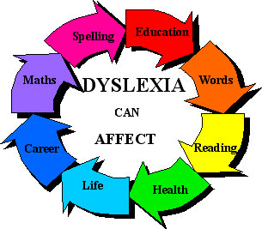

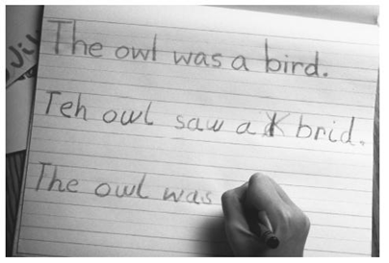
Developmental reading disorder
Developmental reading disorder, also called dyslexia, is a reading disability that occurs when the brain does not properly recognize and process certain symbols.

Causes, incidence, and risk factors
Developmental reading disorder (DRD), or dyslexia, occurs when there is a problem in areas of the brain that help interpret language. It is not caused by vision problems. The disorder is a specific information processing problem that does not interfere with one's ability to think or to understand complex ideas. Most people with DRD have normal intelligence, and many have above-average intelligence.
DRD may appear in combination with developmental writing disorder and developmental arithmetic disorder. All of these involve using symbols to convey information. These conditions may appear alone or in any combination.
DRD often runs in families.

Symptoms
- Difficulty determining the meaning (idea content) of a simple sentence
- Difficulty learning to recognize written words
- Difficulty rhyming

Remedies
- Perform a complete medical exam, including a neurological exam
- Ask questions about the person's developmental, social, and school performance
- Ask if anyone else in the family has had dyslexia

Treatment
- Extra learning assistance, called remedial instruction
- Private, individual tutoring
- Special day classes

